Audrey Guerrero
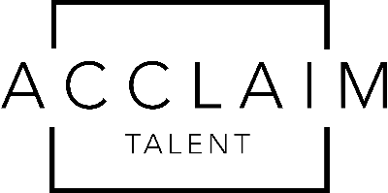
Hair: Brown
Eyes: Brown
Height: 5’2”
Weight: 100
Film________________________________________________________________________
Stood Up Lead (Dir.) Karenna Mudd
Personal Effect Lead (Dir.) Stephanie Burnes
Risk Averse Supporting (Dir.) Arielle Alexis Adame
Social Lead (Dir.) Ali Cooley
Television_____________________________________________________________________
The Eleven Recurring (Dir.) John Choi, Nicolina Lanni
Stage_________________________________________________________________________
Bluefinger Holly The Catastrophic Theatre
The Insanity of Mary Girard Mary Girard Pearland Theatre
Othello Lodovica Zoom Shakespeare
Victor/Victoria Ensemble Playhouse 1960
Children of Eden Ensemble Kirkwood Music Services
Alice in Wonderland Card Pearland Theatre
Print_________________________________________________________________________
Steelcase Furniture Student
Training______________________________________________________________________
Lesly Kahn & Co. Comedy Intensive, Technique Clinic
Next Level Acting Studios On-Camera Technique and Scene Study Shelley Calene-Black, Deke Anderson
Broadway Artists Alliance Adult Professional Workshop
The Clyde Bernardy Acting Studio From Pre-read to Table Read Marlana Hope, Jamie Castro
The Casting Director’s Cut Pilot Season Prep: The Intensive Ramani Leah
Studio Theatre Acting Conservatory-Young Actors
Special Skills__________________________________________________________________
Singing, Dialects (Southern, British, Australian, Irish), Basic Stage Combat, The Simpsons Expert

