Rebecca Blackmore BlackmoreBlackmore
phone: 1-512-573-3621
email: Rebecca.blackmore@icoud.com
160 West Bartlett, Buda, Texas 78610
Professional Experiences

Film/Commercial:
- The Hook Line Sinker-Jan. 2020- Played the Waitress
- Saving Salvador – March 6. 2020 – Played a Customer
- Tele-Novela Commercial-US Census Bureau-Feb 27,2020-Played the main character the Grandmother/Mother
- The Life of Juana –Produced for Go Austin Vamos Austin
- The Eye of a Roman
- Marisol – Role: Detainee

Prior Professional

Experience: Bilingual Special Ed & Prek Teacher with Austin & Hays ISD (2010-2018)
- Provide for appropriate learning experiences to promote cognitive abilities for student with disabilities
- Prepare Individual Educational Plans & Facilitate the Annual Review Dismissal meetings
- Conduct student assessments and monitor student progress
- Employ special educational strategies and techniques during instruction to improve the development of sensory, perceptual-motor skills, language, cognition and memory
- Implemented the Prek Program/ Head Start curriculum and performance standards

Public Servant, Investigator & Quality Assurance with

Texas Workforce Commission (1983 -2008) –
- Conducted fact-finding investigations and prepared administrative reports.
- Performed reviews of unemployment insurance claims in compliance federal and state rules
- Conducted Single Audits Reports
- Performed quality assurance assessments on multiple levels.
- Interviewed, classified and provided job placement services to customers

Goals
The opportunity transfer my life long professional and personal experiences to the film industry, focusing in Acting roles in any capacity.
Skills
- Bilingual: English/ Spanish
- Computer Skills
- Picker/Vendor,
- Upcycler, & Painter

Education

Texas State University –San Marcos – BBA in Management, June 2009

El Paso Community College –AA in Liberal Arts, May 1988
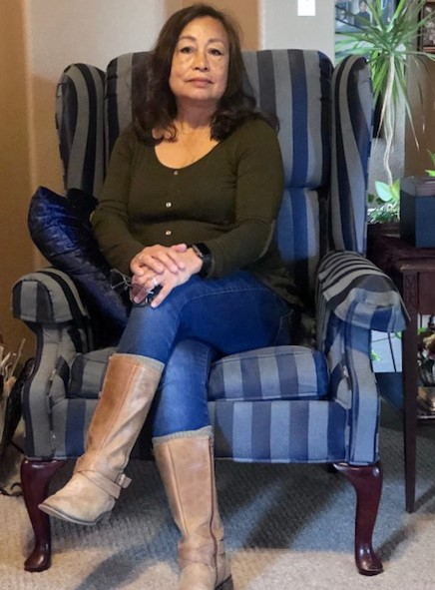
Height- 5’3’’; Weight -135 lbs; Eyes & Hair – Brown; Shirt size – Medium; Pant, Dress & Shoe Size
Traininggg
On Camera Cold Read Audition Workout for Film & Commercial – 4 hr class with Michael Casting

