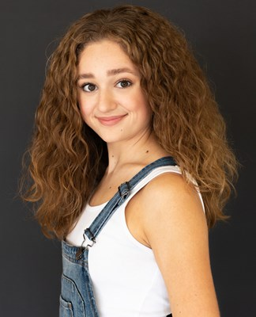

Alyssa Hurtado
Hair color: Dark blonde Eye color: Hazel Voice Type: Mezzo Soprano
alyssabhurtado@gmail.com / alyssa14beth@gmail.com
Musical/Theatre
THE WIZARD OF OZ Dorothy Gale RRHS/Johanna Whitmore
ALMOST MAINE Rhonda RRHS/Johanna Whitmore
LOVE/SICK Maddie RRHS/Johanna Whitmore
13: THE MUSICAL Kendra Palace Theatre/Jessie Drollette
TARZAN Dance Captain RRHS/Johanna Whitmore
FOOTLOOSE Soloist 1/Cowgirl Palace Theatre/Jonathon Young
KISS ME, KATE Dance Ensemble RRHS/Johanna Whitmore

Commercial/Film
SCOUT - SSA Short Film Nikki Allen Robertson
DELL/BLUE INSPIRON Gen Z Friend Beth Sepko
ACE IT - SaulPaul Music Video Teen Ashton Rodger Woodruff
MOON-CALF Olivia Ander Echeverria

Vocal-Dance-Theatrical Training/Experience
Long Center Select Ensemble
Voice Training: Private vocal lessons from Dr. Ellie Shattles, Rose Yurcina, Classical voice class Sarah Stokes
Dance Training: Drill Team- Round Rock High School Dragonettes,The Dance Works and The Dance Spot studio classes- jazz, contemporary, ballet, leaps and turns, drill team prep
Acting Training: Zach North Acting Conservatory, Write, Shoot, Direct camp (Zach Theatre), RRHS Musical Theatre I-IV and Production I-IV

LEADERSHIP
Thespian Troupe 3543 President
Dance Captain

SPECIAL SKILLS/INTERESTS
City of Round Rock Lifeguard, drill team experience field performances and competitions (kick lines, precision dance), Aquatex Swim Team, WMS Cheerleading Team, WMS Orchestra cello 1, RRHS American Sign Language

