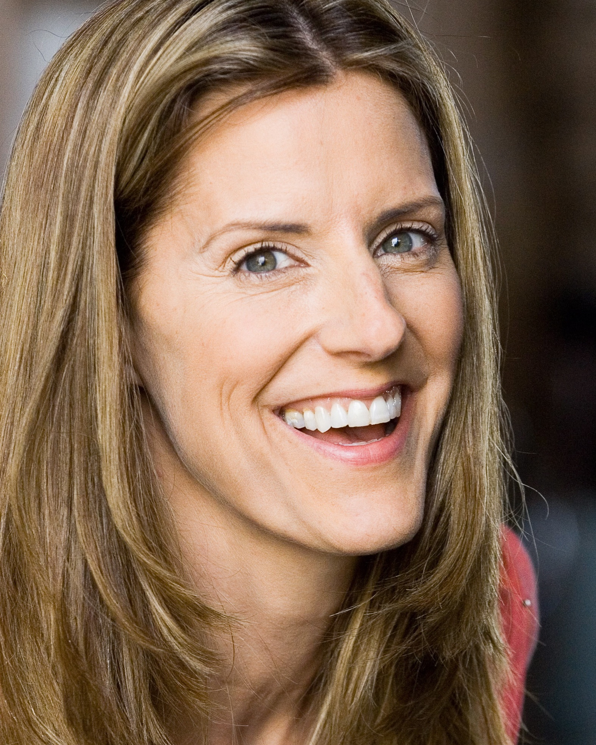 Laurie Foxx
SAG/AFTRA Acclaim Talent 504.267.1634 info@acclaimtalent.net

acclaimlouisiana@gmail.com

Film
The Open Road(J Timberlake,JBridges)Supporting Michael Meredith, AquaFoxx
Red, White and Blue Supporting Simon Rumley, Fidelity/Rumleyvision
New Orleans, Mon Amour Supporting Michael Almereyda, VooDoo Productions.
Portal Supporting Geoff Schaaf/Windchill Films
Read On Lead Jeff Faulkinbury/Seven and a Half Seals
Real America Lead Saint OBI Productions
The J.R. Richards Story Supporting Greg Carter/Bellenger X
The Broker Lead-the Broker Dwayne Smith
Letters to Lauren Lead Miranda Spiegner/Lifeline Films
The Pelican Box Lead Tiffany Kilcoyne/1-4-3- Productions
Remembering Walter Lead Michelle Abram/Abram Productions
Facts of Life Lead Noe Tuch/Ink City Productions
Heaven Sweet Lead Miranda Spiegner/Letters Productions

Television
Theory (Sit-com PILOT) LEAD Richard Boyd/Aqua Foxx Productions
Fresh Catch (Pilot) Series Regular Mike Friedman /Fresh Catch Productions
History By the Roadside (Pilot) Series Regular PBS/H.R. Bass/Chalk Peak Productions
Weeknight Edition Guest Star PBS/Julie Coan/
TV Junkies Guest Star Andre Meadows/Anshawn Ent.
Eat Art (Pilot) Guest Star PBS/Miranda Spiegner/Lifeline Films

Host/ Spokesperson
The Laurie Foxx Show (Pilot) Host Gary Parker/Quanah Productions
Streaming Metro Spokesperson Gary Parker/Quanah Productions
The Independent Professional Host PBS/Edward Nicholas
Dixie’s Roadhouse Café Spokesperson Jenkins Production/Holgen

Commercials and Industrials, VO and addl Film/TV

complete list upon request

Special Talents and Skills
Dialects: Southern, (Proper, Texan, Redneck), Midwest, and Standard American!
Music: Singer/Songwriter(4Cds/mezzo Soprano), Studio Vocalist, Pianist, Guitarist, Whistler
Sports: Horseback (Bareback, English, Western), Dance, SCUBA, spear fishing, jet ski
Other: Singer/Songwriter TV Talk Show Host, Valid and Well-Used Passport.

