RICHARD SELLERS
SAG-AFTRA

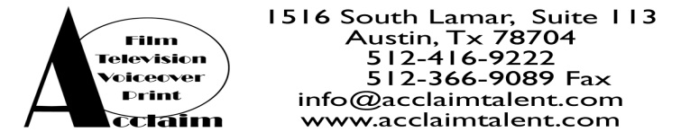
FILM/TELEIVISION:
“Ruth’s Locket” Supporting Gene Burns
“Adventures of A Teenage Supporting Razor Sharp Productions
Dragon Slayer” Andy Lauer
“Friendship!” Supporting Duetsche Columbia
Markus Goller
“The Flock” Stunt Double Wai Keung Lau
“Everybody Hates Chris “ Featured UPN
Eric Laneuville
“Wildfire” Guest Star ABC
Nick Marck
Into the West Supporting Dreamworks
“Hell on Wheels” Michael w. Watkins
“The Alamo” Supporting Touchstone
(Uncredited) John Lee Hancock
“Angel” Featured 2oth Century Fox
“Westown” Supporting QuarterhorseProductions
“O Brother” Supporting Once in a Blue Moon
Productions
“As The Wart Grows” Supporting On Hands Production

Stunts:
“Adventures .of A Stunts Razor Sharp Productions
Teenage Dragonslayer” Andrew Lauer
“The Flock” Stunt Double Wai Keung Lau, Director
Into the West Stunts Dreamworks
“Hell on Wheels” Michael w. Watkins
“The Alamo” Utility stunts Touchstone
John Lee Hancock
Commercial/Print/Industrial:
On Request
Theatre: (More on Request)
Holly and the Ivy Chorus San Jacinto College
Hansel and Gretel Hansel-Lead Tidehaven Theatre
Winners,Losers, & Games Bob-Lead Tidehaven Theatre

Training: (Skills and special abilities on Request) *Can talk/sound just like Smegal from “Lord of The Rings”
(Comedy intensive) ((L.A.)Leslie Kahn & Company) (Acting I) Dr. Lemaster, SJC
(Character Analysis) Jo Edna Boldin (On Camera) Robin Craig
(Character Analysis/ongoing Camera) Mona Lee (Commercials) Caryn Gorme
(Audition Training) Barbara Brinkley (Intensive Coaching) Eic Lutes
(Commercial/ Film Class) Lee Peterson (Intro to Motion Pictures) Dr. Ivin, SJC

